2-Model Overview

Objectives

The object of LANDCARB 2.0 is to simulate the accumulation of carbon over succession in a landscape with mixed species-mixed aged forest stands and spatially variable climate, soil, topography, and history. This version of the model is currently parameterized for the Pacific Northwest. There is no reason, however, that it could not be used for other types of forests as well. The model can be used to investigate the landscape level effects of various regeneration strategies, harvesting, herbiciding, salvage, patch cutting, tree species replacement by design or by natural succession, site preparation, and wildfires.

The model provides output on seven live state variables, nine detritus (partially decomposed) state variables, three stable (highly decomposed) state variables, two charcoal relate variables and the volume harvested (see Output files section for more details).

LANDCARB incorporates the notion of multiple biological levels that each contribute to how carbon changes in forests (Table 2-1). Many carbon models incorporate at least several biological levels, typically physiological and ecosystem ones. LANDCARB is somewhat unsual in that it includes five: physiological, population, community, ecosystem, and landscape. Through various parameterization of the model, it is possible to remove several of these biological levels, allowing to one to test the kinds of behaviors that disappear when they are removed.

Table 1. Levels of biological organization and their contribution to LANDCARB behavior.

Physiological-response to changes of climate, radiation, soil in space and time

Population-variable colonization rates, mortality rates, and heart-rot formation

Community-species changes in space and time (i.e., succession)

Ecosystem-flows of carbon, effects of disturbance

Landscape-propagation of disturbances, dispersal of seeds

Basic Approach
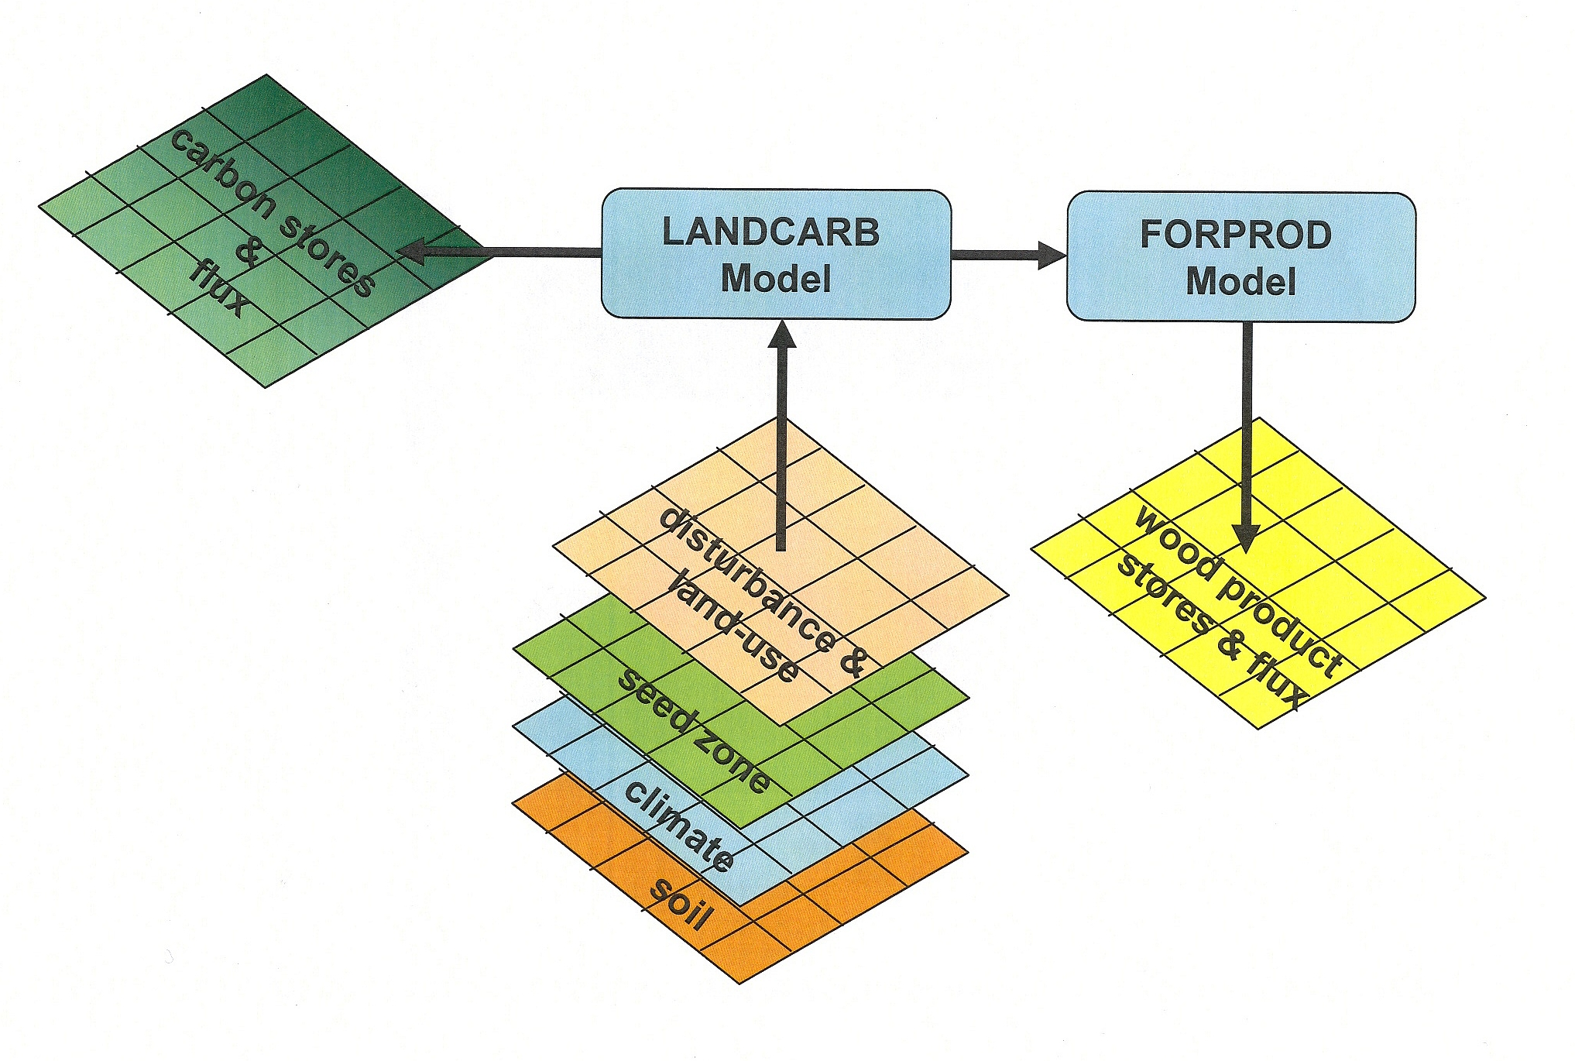
Figure 2-1. Relationship between spatial input and output data and the LANDCARB model. In the case of the Forest Sector Carbon Calculator, all spatial input data is assumed constant except for disturbance and land-use. A variation of the FROPROD model is used to estimate wood product stores, balances, and related biofuel offsets.

The approach used in LANDCARB 2.0 is to divide the landscape into a grid of cells, each grid representing a stand. Each stand is part of a specific climate, soil, radiation, disturbance and seed zone (Figure 2-1). The interactions of climate, soil, and radiation are modeled at the zone level and then applied to individual stands. Disturbance zones are used to characterize the sub-landscape disturbance regime, although the particular effect of each disturbance is calculated for each stand depending on its state and that of its neighbors. Seed zones specify the seed sources likely to be be present and their abundance, but as with disturbance the actual seed sources are dependent on the state of neighboring cells. Within each stand the abundance of different plant life forms is simulated by tracking colonization, growth, and mortality. Disturbances can create within-stand heterogeneity representing disturbances that do not kill the entire stand of trees. These cohorts of tree regeneration are allowed to interact to mimic the effect of older cohorts on younger cohorts.

LANDCARB 2.0 has a number of levels of organization it uses to estimate changes in carbon stores within a landscape (Figure 2-2). At the highest level there is a landscape comprized of stand grid cells, each which represents part of a stand of trees (given this is a raster or gridbased landscape depiction, a stand is any set of adjacent cells which have a similar species composition, environment, and disturbance history). Each stand grid cell belongs to a 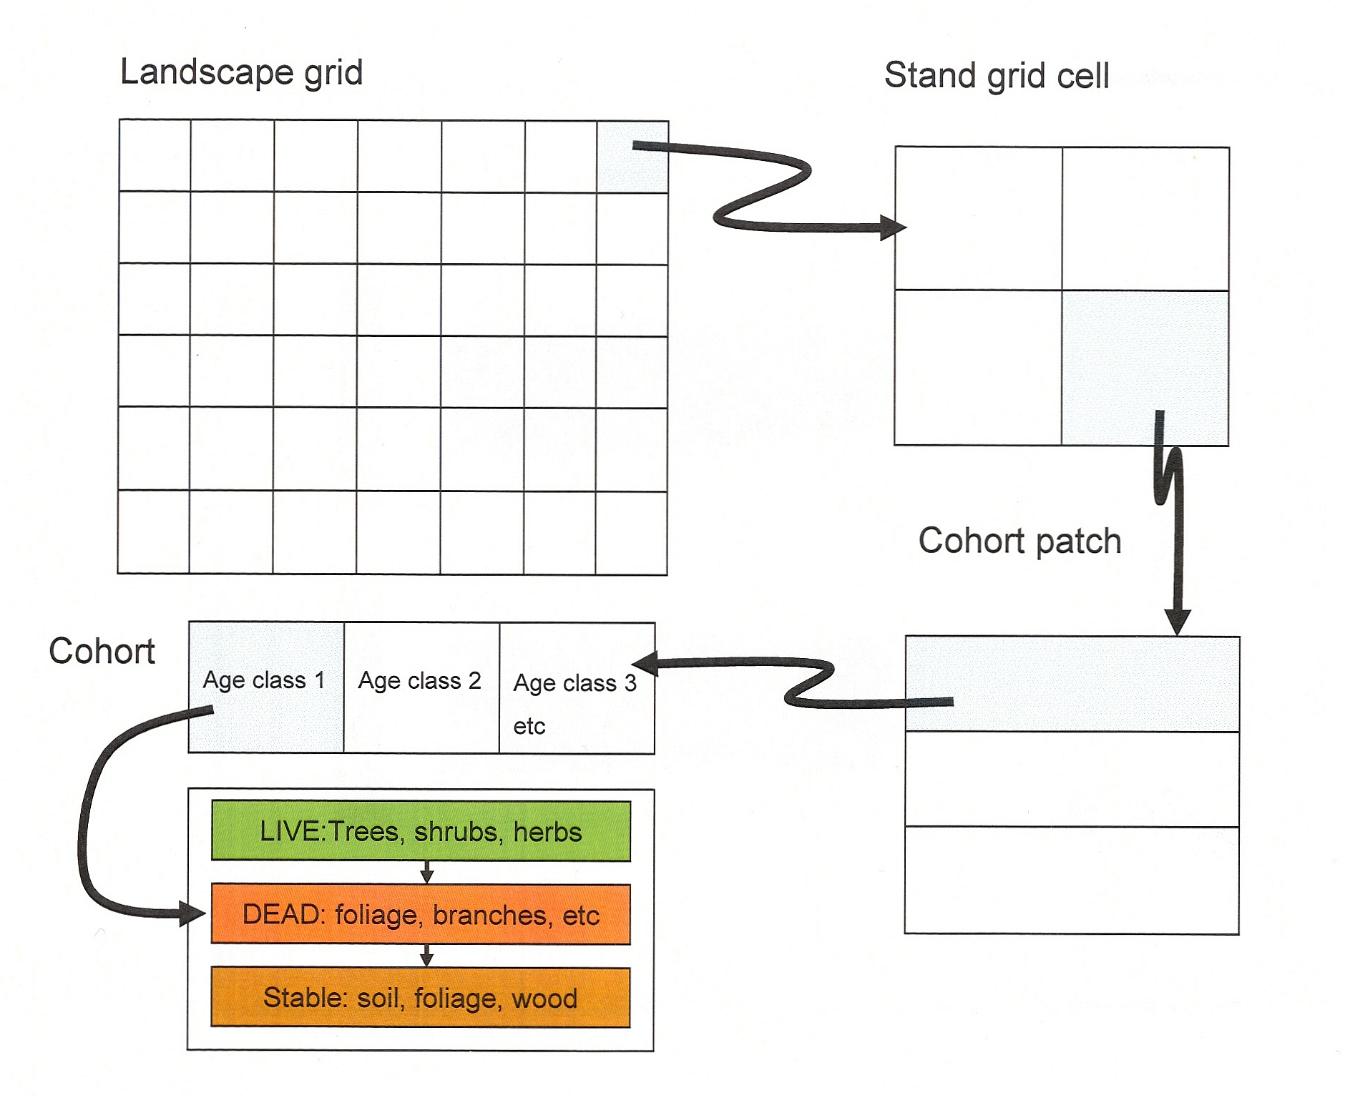 Figure 2-2. Spatial, temporal, and carbon pool units used within the LandCarb model.

series of zones describing key landscape attributes (disturbance regime, climate, soil, radiation, seed sources, etc). Each stand grid cell contains a number of cohorts (in the program this is called a cohort set) that represent different episodes of disturbance and colonization. Each cohort contains up to four layers of vegetation each having up to seven live parts, eight dead pools, three stable pools representing highly decomposed material, and two pools representing charcoal. The four layers of vegetation that can occur in each cohort are upper trees, lower trees, shrubs, and herbs. The two tree layers can have different species, whereas the shrub and herb layers are viewed as each representing a mix of species. Each cell can have any combination of layers except that lower trees can only occur when upper trees are present. Each layer of plants has an age-class structure reflecting gradual colonization of each cohort.

Each of the layers in a cohort can potentially have seven live parts: 1) foliage, 2) fine roots, 3) branches, 4) sapwood, 5) heartwood, 6) coarse roots, and 7) heart-rot (Figure 2-3). To make the layers correspond to the actual structure of certain life forms, herbs are restricted from having woody parts and shrubs cannot have heartwood or heart rot (as they do not form
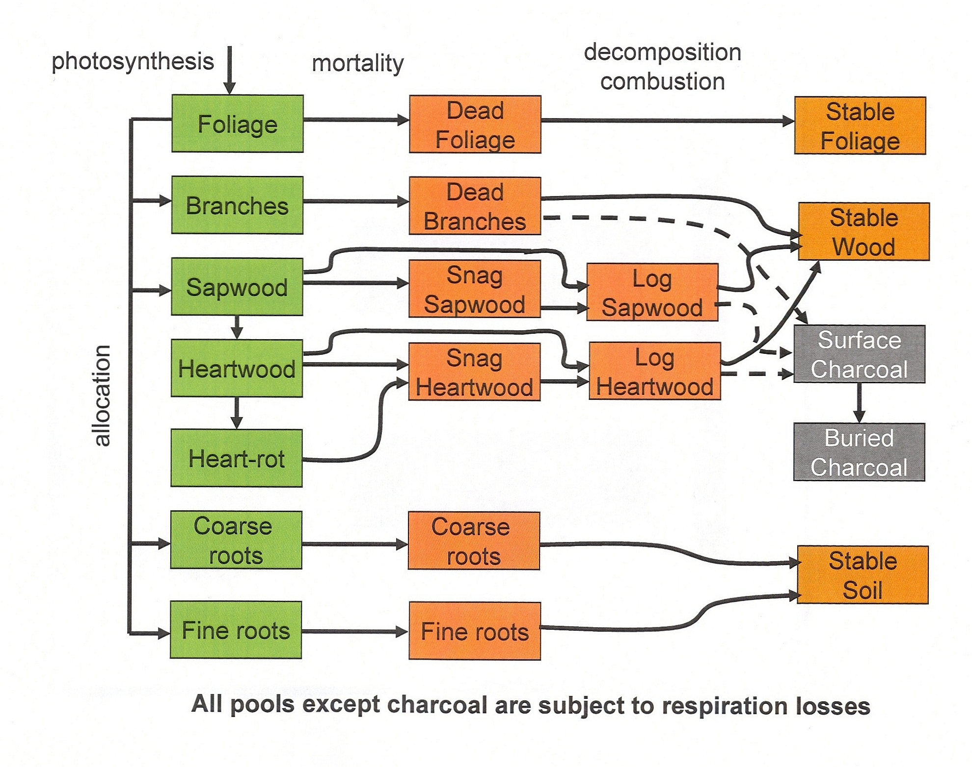
Figure 2-3 Pools of carbon tracked within LANDCARB and the processes controlling the flow of carbon between them.

a bole). All the live parts correspond to parts typically reported in the ecological literature with the exception of the bole. The later would be composed of sapwood, heartwood, and heart rot. In our model heartwood includes the heartwood and the outer bark as these are non respiring, decay-resistant layers. The sapwood includes the sapwood and the inner bark layers as these are respiring and decompose relatively quickly compared to outer bark or heartwood. Heart rot represents the portion of the heartwood that is being degraded by parasitic and saprophytic fungi inside the living trees.

Each of the live parts of each layer contributes material to a corresponding dead pool. Thus foliage adds material to the dead foliage, fine roots to dead fine roots, branches to dead branches, sapwood to dead sapwood, heartwood and heart rot to dead heartwood, and coarse roots to dead coarse roots. Rather than have every plant layer in each cell have its own dead pool, we have combined all the inputs from the layers of the cell to form a single detrital pool for each plant part. For example, the foliage from the four plant layers feeds into a single dead foliage pool. We have also separated dead sapwood and dead heartwood into snags versus logs so that the effects of position on microclimate can be modeled. Snags and logs are further divided into salvageable versus unsalvagable fractions so that realistic amounts of dead trees can be removed during simulated salvage operations. All the detritus pools in a cell can potentially add material to one of three stable pools (stable foliage, stable wood, stable soil). The objective is to simulate a pool of highly decomposed material that changes slowly and is quite resistant to decomposition. Finally, fires can create surface charcoal from live parts or dead pools. Surface charcoal can be incorporated into the mineral soil and become protected from future fires as buried charcoal, whereas surface charcoal can be lost during subsequent fires.

Computing Environment.

LandCarb is developed under Microsoft Visual C++ for .NET, using Visual Studio 2005. Most of the program code is written in ANSI C++. A small portion of code, which manages the user interface, is written in C++/CLI. LandCarb is distributed as an executable program with supporting libraries. It runs under Microsoft Windows XP and requires version 2.0 of the .NET Framework (this is available as a free download at www.microsoft.com).

Model Module Overview

LANDCARB 2.0 consists of a number of modules which perform specific functions (Figure 2-4). The following section describes the general purpose of each module. A fuller description of each can be found under the Model Documentation section.

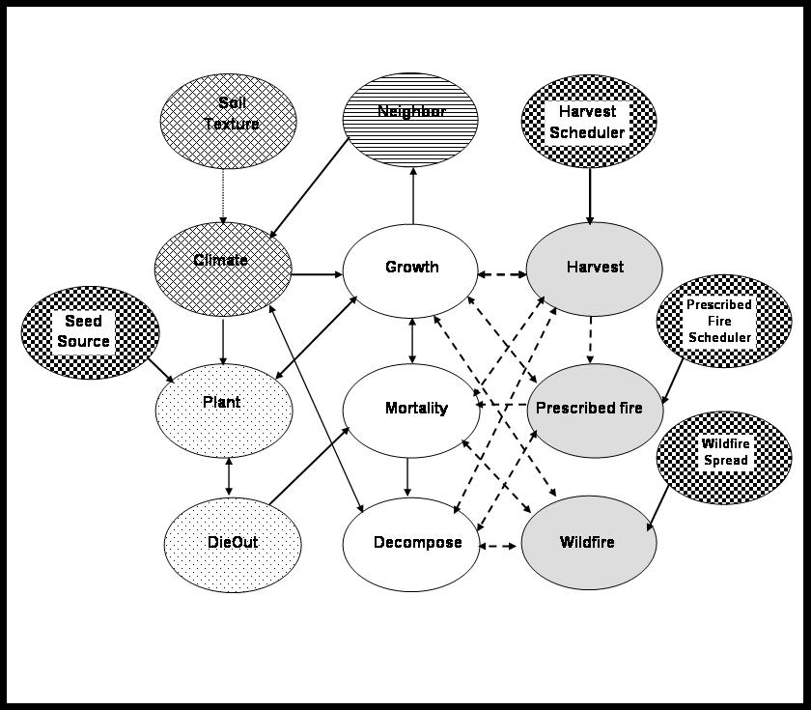

Figure 2-4. Relationship of the the modules used in the LANDCARB model.

Climate. The purpose of this module is to determine the effect of climate on tree species establishment, growth, and decomposition. Climatic effects are calculated for each combination of climate-, soil-, solar radiation-zone assuming an old-growth stand structure. The results are then used for each stand grid cell that belongs to this combination of zones.

SOILTEXTURE. This module is used to calculate the effects of soil texture, depth and rockiness on the water holding capacity of soils in a soil zone. These results are used by the CLIMATE module.

Plant. This module determines the age-class structure of plant layers in a cohort. The age-class structure of all layers is based on a fixed probability. Each cohort is given a limited time to have its layers established and if all the area is not used in the allotted time, then a new cohort is established. This assures that each cohort has a narrow age range and age classes will be compariable in terms of size, species, etc. The upper tree layer is planted at the same time as the lower tree layer. This is unlike STANDCARB, in which the lower tree is always planted after the upper tree. The probability of a tree species colonizing a site is a function of shade tolerance, temperature, moisture limits, and the local abundance of species in surrounding stand grid cells.

DieOut. The purpose of this module is simulate the upper tree layer dying out in a cohort. This reflects the fact that above a certain age, trees are unable to spread horizontally. When trees in this state die either through normal mortality processes or disturbance they can not replace themselves, hence the area they cover decreases. This allows more light to reach the lower trees and consequently the underlying tree layer grows faster and eventually assumes dominance relative to the upper tree layer. This allows LANDCARB 3.0 to simulate species replacement within a cohort.

Growth. This module determines the rate that living plant parts grow in a cohort. The living parts tracked by the GROWTH module include foliage, branches, sapwood, heartwood, heart-rot, coarse roots, and fine roots. The rate of growth is dependent upon the amount of foliage within a cohort and the maximum rate of net production as determined by the CLIMATE module. The growth of foliage for each layer is dependent on the amount of light it receives, and the layers light extinction rate and light compensation point. Foliage mass is adjusted to reflect the lags in growth caused by the age-class structure.

Mortality. This module determines the rate of detrital production when a cohort has not been harvested or burned. For foliage and fine roots, a fixed proportion is assumed to die each year. These proportions are functions of the species (e.g., deciduous trees and herbs lose all their leaves each year). The proportion of branches, and coarse roots lost to pruning is a function of the light environment, as calculated in the GROWTH module, so that as the light passing through the foliage of a layer approaches the light compensation point, the pruning rate reaches a maximum. The proportion of bole-related parts, branches, and coarse roots lost to mortality varies with tree age. Initially mortality is a function of the light environment, so that as the light passing through the foliage of a layer approaches the light compensation point, the mortality rate reaches a maximum. Once trees reach their maximum horizontal extent, mortality is determined from the maximum age of trees. The transition from one form of mortality (i.e., density dependent to density independent) is influenced by the age-class structure of the tree layers. The mortality function also determines the proportion of trees dying from natural causes that form snags versus logs. This is a function of the zone a stand grid cell occurs in and the age of the cohort.

Decompose. This module determines the balance of inputs from normal mortality, harvesting and fires, and the losses from decomposition and fire for each cohort. These balances are calculated for each of the eight detritus pools (dead foliage, dead fine roots, dead coarse roots, dead branches, dead sapwood, and dead heartwood; the latter two subdivided into snags and logs) and three stable pools (stable foliage, stable wood, and stable soil organic matter). In addition to these 11 pools, this module calculates total detritus (excludes stable pools), total stable, and total dead stores. The MORTALITY, HARVEST, PRESCRIBED FIRE, and WILDFIRE module are used to calculate detritus inputs. The rates of decomposition of each pool are determined by the species contributing detritus to a plot, and climatic effects as calculated in the CLIMATE module. Losses from fires are determined by the SITEPREP module. Lags associated with the formation of stable material, degradation of salvageable wood, and snag fall are approximated by altering the relevant transfer rate-constants when inputs exceed the long-erm average value.

Harvest. This module determines how a stand grid cell is to be harvested or salvaged and the amount of live plant parts removed from each cohort versus the amount added to detrital pools. Harvest can remove part or all of the upper or lower tree layers and dead wood that is salvagable. For each simulation, the user can set the levels of utilization standards (the amount cut and removed). Only sapwood and heartwood (i.e., boles) either alive or dead can be removed from the simulated forest. All other living pools (leaves, branches, fine roots, and coarse roots) are transferred to the appropriate dead pools after a harvest.

Prescribed Fire. This module determines the effect of prescribed fires in a cohort. Prescribed fires can occur on their own or after timber harvest. This module kills plant layers, burns live parts as well as dead and stable pools, and forms charcoal.

WILDFIRE. This module determines the effect of wildfires fires in a cohort. This module kills plant layers, burns live parts as well as dead and stable pools, and forms charcoal.

Neighbor. The purpose of this module is to determine the overall light environment of a cohort and the interaction with neighboring cohorts and stands. The degree of blocking of light is determined by the relative height of cohorts and the average distance between cohorts. A similar process is used to determine the influence of one stand gird cell upon another. Height of the tree layer is a function of the age of that layer in a cohort. The tree height of a stand grid cell is the average height of all the cohorts in a stand grid cell. The average distance between cohorts is determined from the number of within stand grid cell patches a disturbance forms. The greater the number of patches, the shorter the average distance between cohorts. The distance between stand grid cells is determined by the stand grid cell width used to portray the landscape. The heights and distances are used to compute the average angle between cohorts or stand grid cells. The steeper the angle, the lower the light amount passed onto the lower cohort or stand grid cell.

Seed Dispersal. This module determines the mixture of species and the abundance of tree seed sources. Seeds are assumed to originate from neighboring cells, the maximum dispersal distance determines the number of neighboring stand grid cells considered. For carbon calculator runs, this module is turned off.

WildFire Scheduler. This module determines when and where a wildfire occurs. The occurrence of wildfire is random, but determined by an average interval between fires. In addition it determines the most likely fire severity that will occur.

Harvest Scheduler. This module determines when and where a timber harvest occurs. In addition it determines the harvest level employed.

PRESCRIBED FIRE Scheduler. This module determines when and where a prescribed fire occurs. Prescribed fire can occur after harvest as a site preparation step or be independent of harvest.

ECOSYSTEM FLOWS. This uses data produced by the model to calculate important ecosystem flows related to the carbon cycle of forests such as net primary production (NPP), heterotrophic respiration (Rh), and net ecosystem production (NEP). This allows one to compare results to other forest ecosystem models and field data.

